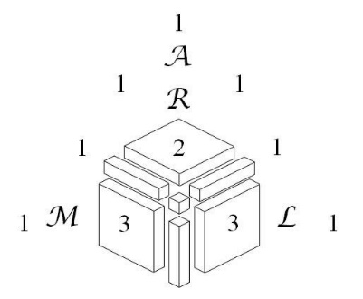

PENN STATE 2023 Bill

REGION NAME(S) ____________________________________

# OF TEAMS **______**

# OF STUDENTS **______** X $160 $ **________**

# OF NON-VOLUNTEER ADULTS FRIDAY **______** X $120 $ **________**

NUMBER OF PEOPLE IN DORM THURSDAY

SINGLES **______** X $34.50 $ **________**

DOUBLES **______** X $31.50 $ **________**

NUMBER OF PEOPLE IN DORM SATURDAY

SINGLES **______** X $34.50 $ **________**

DOUBLES **______** X $31.50 $ **________**

AMOUNT PREPAID $ **________**

**TOTAL FEES FOR ARML 2023 DUE AT MEET $ ________**

AMOUNT STILL OWED $ **________**

Please remit to:

Linda Berman

ARML Treasurer

241 Central Park West APT 17E

New York, NY 10024-4826